# Introduction

The website is about a small indie game development team located in Sligo Town, Ireland. The website will include the portfolio of the game team which showcases artwork and projects, will include a small about page and a contact page, and a home page.

# GitHuB – must be included in order to mark your web project

GitHub URL to open your website on a browser

https://mnoor112.github.io/WFMyWebsite/index.html

URL of your GitHub Repository

# <https://github.com/mnoor112/WFMyWebsite>

# Original Mockup Sketch of Website home page

# Website Described

Page 1 – described the purpose of the page and where you got your information and images from

Home page – A little information about what the website is and what you can do, and displaying an image taken from google images. The links to the images are located in the code.

Page 2 - described the purpose of the page and where you got your information and images from

Portfolio- This page has images representing the “work” of the development team, with a youtube iFrame video aswell.

Page 3 – described the purpose of the page and where you got your information and images from

About- This page contains information about the development team.

Page 4 – described the purpose of the page and where you got your information and images from

Contact: This site is for contact information of the development team, contains a google maps interactive using iframe.

# HTML5 Validation Results for each Webpage

Page 1 – –Validations result (with the majority of the errors resolved)

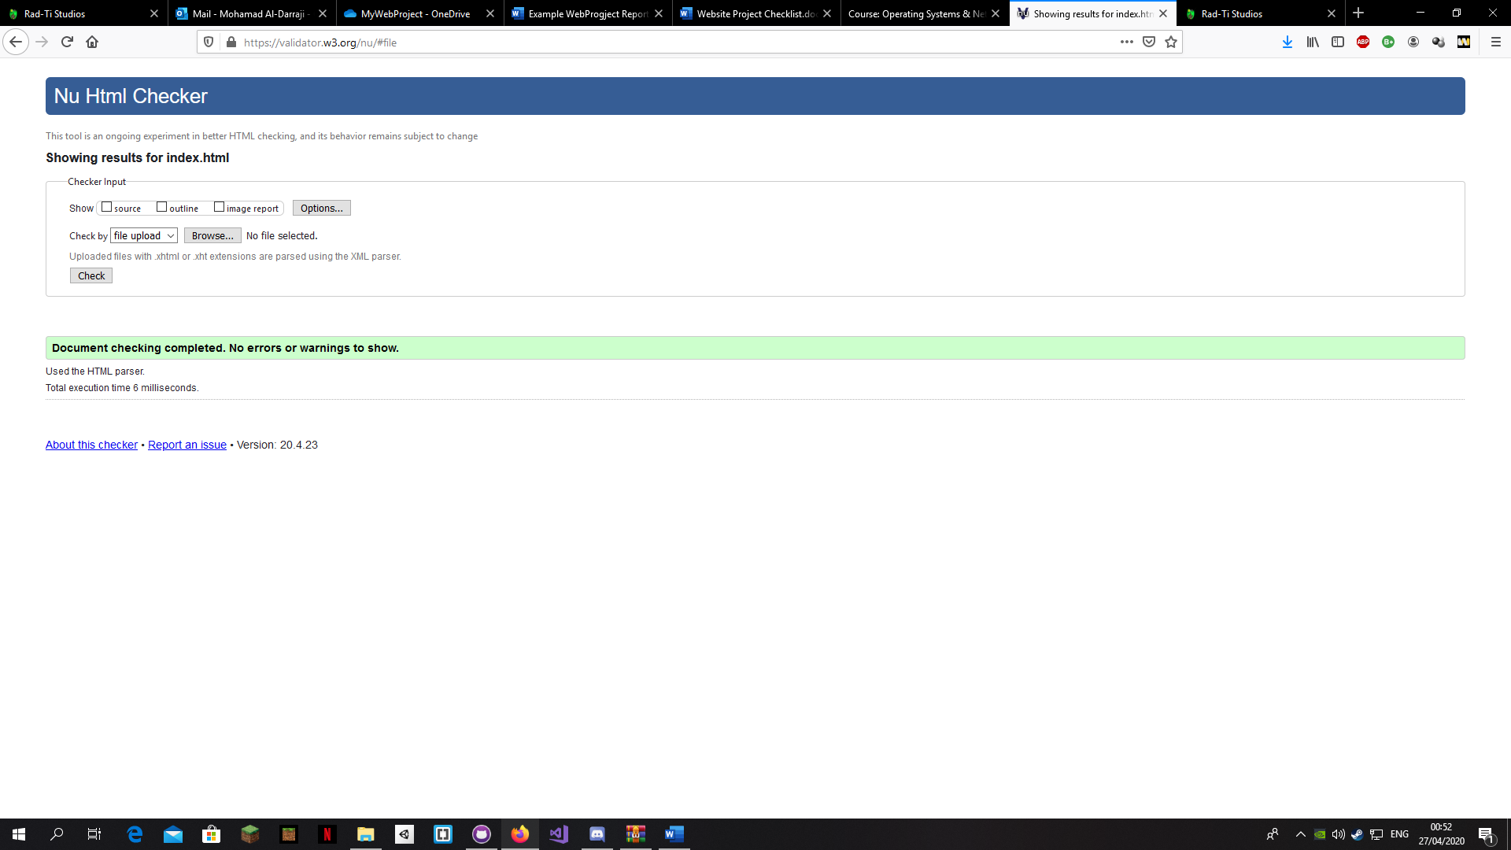

Page 2 – Validation result

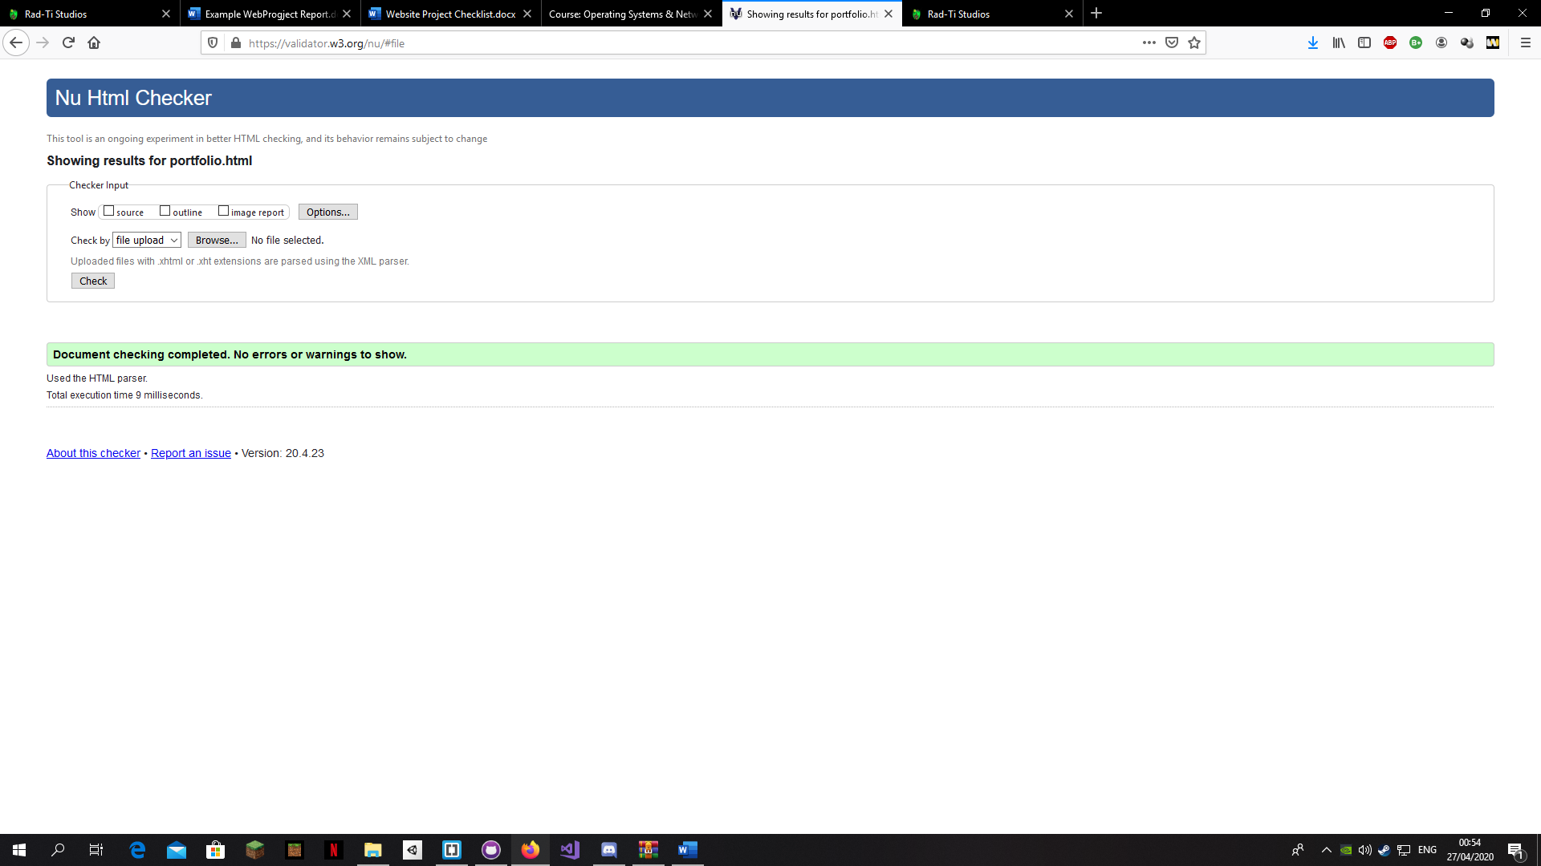

Page 3 – Validation result

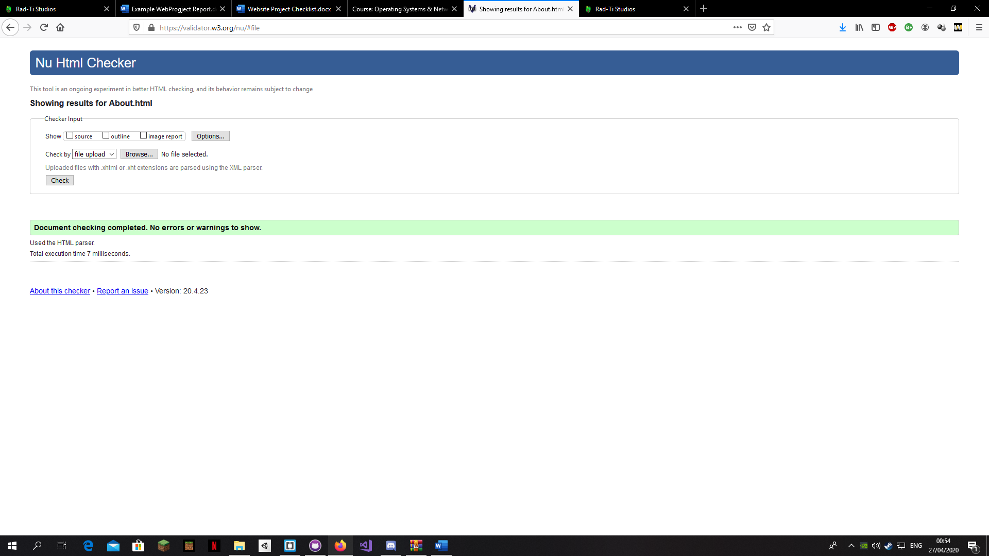

Page 4… Validation results

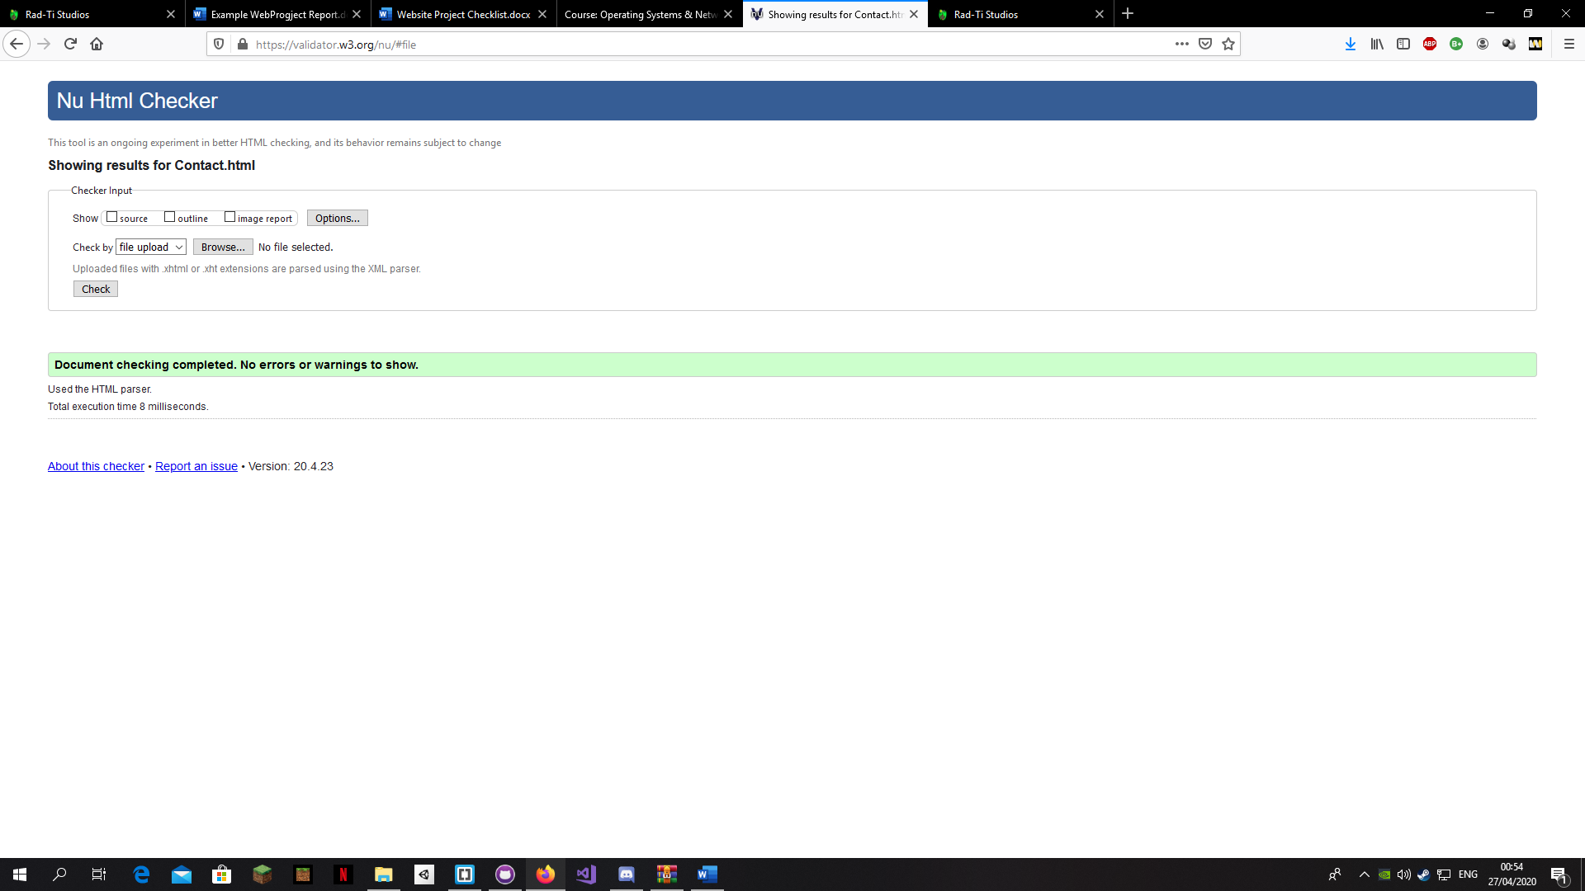

# CSS Validation Results

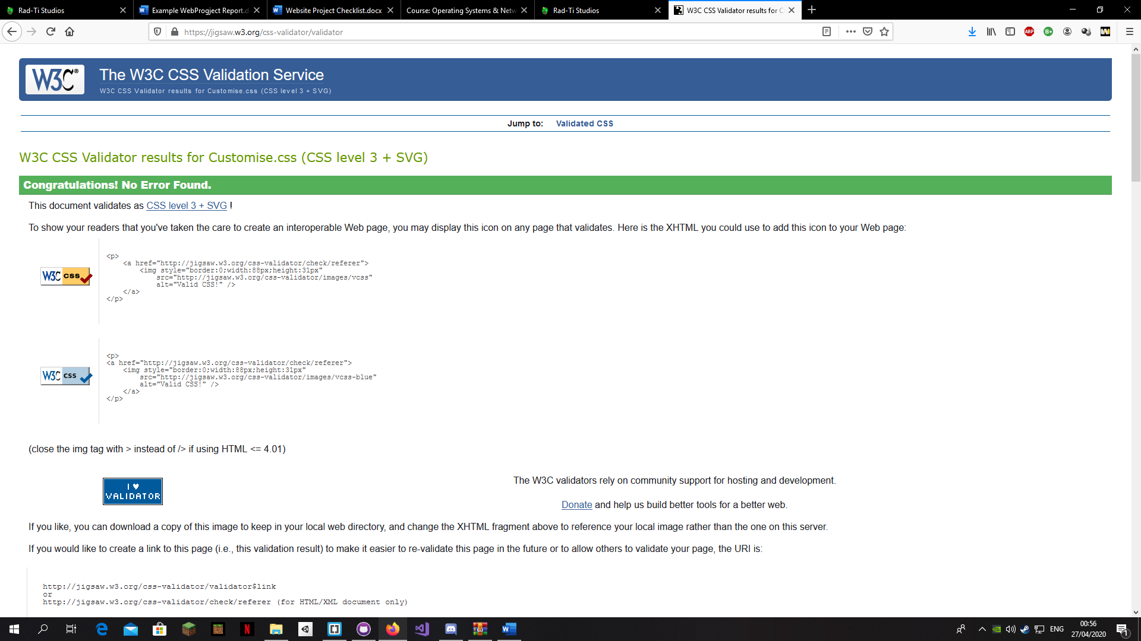

# Include Project CheckList – outline where feature are on Website to ensure they are found and marked

**You are asked to complete an original website of your own work, the website should contain the features listed below.**

Create a website using html5/css that will include the below Project Check List elements: if features are not obvious outline where they are located on the web page below. In order to mark the project the student will present the website and explain the code, declaration of own work submitted.

|  |
| --- |
| **\*\*\*\*Must include Report including purpose and intended audience of the website and sources of images and information of each web page and HTML & CSS validation results. Upload entire project to GitHub and upload GitHub url in report** |
| **Minimum of 4 HTML Pages with navigation menu** |
| **Upload progress and completed website to your GitHub account** |
| **HTML5 standards and recommended page layout structure** (header,main,aside,article,footer,etc) |
| **Include appropriate Meta data – description & appropriate keywords etc to improve pages SEO** |
| **Include font family for web page body** |
| **Appropriate use of External Style Sheet – Recommended CSS** |
| **Appropriate use of Internal & Inline Styling on HTML page** (one example of each) HomePage logo style, |
| **Home page content aligned to each other and visually attractive** |
| **Include navigation above fold and bottom of web pages- Indicate on navigation the current page** |
| **Include both Class and ID as CSS Selectors** used in all pages to add specific css styling to specific elementsm, for example red for the <p> tags |
| **Consistency of design on all pages , use of fonts, colour etc** |
| **Appropriate use of Headings (h1, h2, h3, h4)** |
| **Appropriate use of Colours (test for colour blind users)** |
| **Include an article or section with 2 or 3 columns** (by using appropriate css) on the portfolio page, used to separate the different medias (images and video) |
| **Include logo and display in header of page All Pages** |
| **Clear, consistent and align content on all pages** (reference all sources) |
| **Include images (with at least one image floated with text alongside)** floating image on **….** |
| **Use of background image** background image on page 1, 3 and 4 |
| **Include table of data/information** |
| **Include lists ordered or unordered (different shaped bullet points)** on all pages for the navigation bar, unordered |
| **Include a link to a suitable video and google map** Page 2 has video (Portfolio), Page 4(Contact) has google maps |
| **Include a contact me form and include red * beside required/mandatory input fields** |
| **Verify data collected on contact form, using get and data attached to URL** (Use the method get to display values entered on form will be appended to url and passed to server <form action=" [http://year1.ccpdev.me/FormTest.php](http://year1.ccpdev.me/FormTest.php?fdf=fdsaf&fdsfs=hfdsahfkjhfa)" method="get"> |
| **Footer information include Copyright© 2020 and navigation** |
| **Internal anchor Links on one of the webpages** on page 3 (about) there is an anchor link that directs to page 4 (contact), The word is “here” in the “We also take requests to create custom graphic designs here” sentence |
| **External Link** on page 2 (portfolio) and page 1(home pagE) when you click the images it will direct you to the images original link |
| **Any Additional Features included Navigation bar active hover and not hover change colours depending on mouse cursor position and which page is selected** Added on all pages |
| **Results included in report of HTML5 Validation (with majority of issues addressed)** |
| **Results included in report of CSS Validation (with majority of issues addressed)** |
| **Include Favicon on the Title tab** | |
| **Guide line on Website appearance, design and Content** | |
| **Guidelines on Website overall appearance & design** | |